**Name :**

**Hafsa Waseem**

**Roll no:**

**SU92-BSSEM-S24-014**

**Subject :**

**DSA (Lab)**

**Section :**

**3A**

**Submitted to:**

**Sir Rasikh**

**Task :**

**Write a function to insert a node at a specific position in a singly linked list, ensuring valid position handling.**

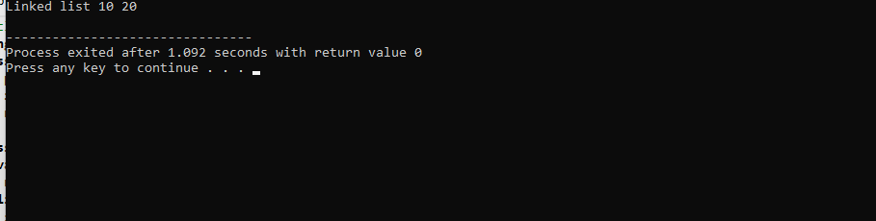

**Explanation :**

A linked list is like chain of boxes ,where each box contains some information and pointer to the next box. When we want to add a new box to the chain, we need to follow these steps are following :

* Create a new box with desired information box.
* Find the correct location in the chain where the new box should be inserted .
* Update the pointers in the adjacent boxes to point to the new box.

The code implements these steps to insert a new box at specific position in the linked list .It checks for valid positions ,creates a new box , finds the correct locations and updates the pointers accordingly .